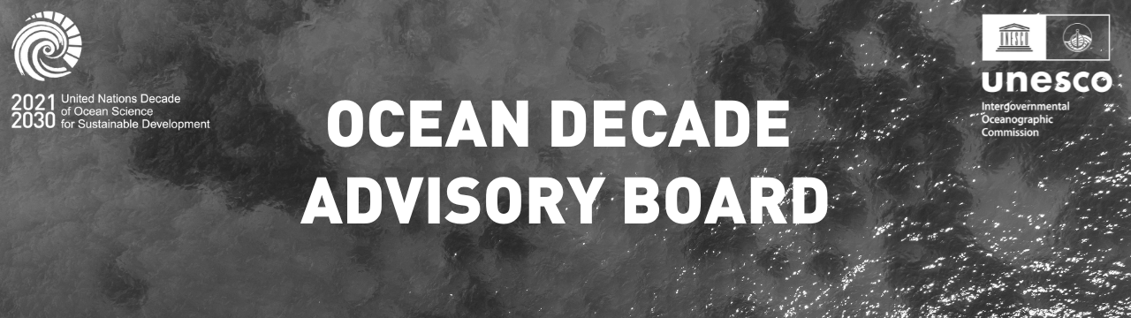

Nomination

2026 - 2027 Decade Advisory Board Nomination Form

Proposals for nominations can be put forward by Member States of IOC-UNESCO, United Nations or United Nations entities, as well as by intergovernmental organizations. Self-nominations will also be possible to encourage nominations from non-governmental entities.

A Selection Panel convened by the IOC Executive Secretary and composed of the IOC Chair and IOC Officers representing the five IOC electoral groups, with the technical support of the Decade Coordination Unit, will be tasked with selecting the expert members of the Decade Advisory Board.

The Selection Panel will ensure that the proposed expert members have sufficient skills, knowledge, influence and impartiality regarding the vision and objectives of the Decade and are able to undertake the work outlined in the terms of reference. Their skills and expertise should cover at least one of the following areas:

1. **Intergovernmental processes and coordination;**
2. **The ocean aspects of sustainable development;**
3. **Ocean science (natural / social dimensions);**
4. **Science-policy / decision / end-user interface and engagement;**
5. **Ocean Economy / finance/ partnerships;**
6. **Innovation / technology/ infrastructure development;**
7. **Capacity development, training and transfer or marine technology, education, communications and outreach; and/or**
8. **Development of large-scale multi/inter-disciplinary international programmes / projects.**

Expert members will be selected with due consideration to expertise, geographic, generational, and gender balance and will serve on a voluntary basis. Membership

on the Decade Advisory Board will be for a two-year term, renewable for a second mandate with membership terms to be staggered.

The call for nominations has been extended and will be open until 30 October 2023 at 23.59h CET

For informational purposes, you can find the PDF and Word versions of this application form [here](https://oceanexpert.org/document/33039).

* 1. Is this a self-nomination?

 Yes  No



Nominator Information

2026 - 2027 Decade Advisory Board Nomination Form

* 2. What type of entity is making this nomination?

 Member State of IOC-UNESCO  United Nations Member State  United Nations entity

 Intergovernmental Organisation

* 3. Contact Details of the Nominating Body

Name of Nominating Body

Contact Full Name

Contact Email Address

Please note that the following questions refer, in second person, to the nominee you wish to put forward. Please answer them about your nominee, not yourself.



Nominee Information

2026 - 2027 Decade Advisory Board Nomination Form

* 4. Nominee Details

First Name

Last Name

Professional Title

Mobile Phone Number (with country code)

Email Address

* 5. Nominee’s Nationality

* 6. Name of Nominee's Employer

7. Nominee’s Gender

* 8. Nominee’s Career Level

* 9. Please upload an up-to-date version of the nominee's CV

*Please submit in PDF format and the file's size should be up to 16MB*

No file chosen

* 10. What sector does the nominee work in?

Please select as many as are applicable

Government

Intergovernmental Organisation Research Institution

Private Sector

Philanthropy Education

Non-Governmental Organisation / Civil Society Organization

 Other (please specify)

* 11. What aspect of the Decade Implementation is the nominee most focused on in their professional work?

You may select up to 3

Intergovernmental processes and coordination

Ocean science (natural and social sciences) (Please specify in the below questions your field of research, experience in inter/multidisciplinary and co-designed initiatives)

Science/policy/decision/end-user interface Ocean economy, financing and partnerships

Innovation, technology advancement, and infrastructure development

Capacity development, training and transfer of marine technology, education

Communications and outreach

Development and resource mobilisation for large-scale multi/inter-disciplinary international programmes/projects

* 12. Please describe the nominee’s field of expertise and your professional experience as relevant to the categories above and describe how it will contribute to the work of the Decade Advisory Board (no more than 200 words per category)
* 13. Please describe the nominee’s motivation to contribute to the Ocean Decade, what kind of strength you will bring to the process, and your experience in building multi- stakeholder partnerships (max 400 words)
* 14. Please describe any previous or existing involvement of the nominee in the Ocean Decade (max 200 words)
* 15. Please upload a statement from the nominee’s employer stating the following

*“ I acknowledge that in the case Ms/Mrs/Mr*  *is selected to serve as a member of the Decade Advisory Board, he/she will be allowed to act in a personal capacity and will not be expected to represent in any way our organization or institution but act in the interest of the community associated with her/his field of expertise”.*

*Name and signature of the representative of the employing structure*

*"*

Please only submit in PDF and the file's size should be up to 16MB.

No file chosen